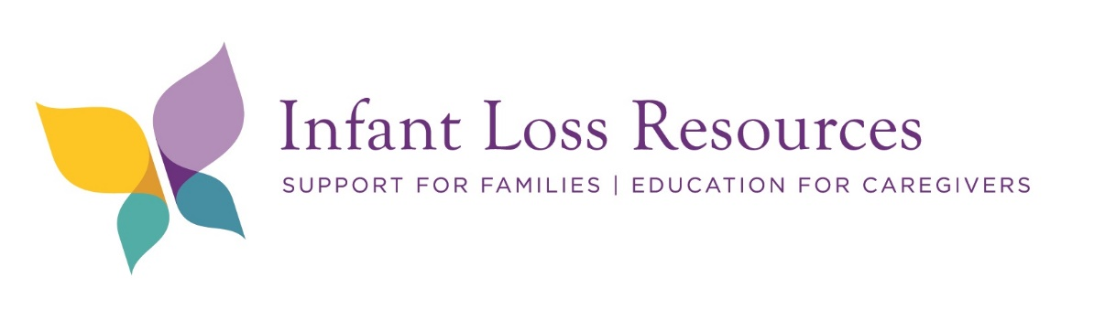

ABC’s of Safe Sleep Train the Trainer Course: How to reduce the Risk of Sudden Unexpected Infant Death (SUID).
One of the greatest risks for infant deaths is an unsafe sleep environment. In fact, nearly half of the babies who died from unsafe sleep were sleeping in adult beds.

Training incudes:
- Current Sudden Infant Death Syndrome (SIDS) and Sudden Unexpected Infant Death (SUID) U.S Data
- American Academy of Pediatrics (AAP) Safe Sleep Recommendations
- Current SIDS research
- Risk Factors
- SUID and Infant Mortality impact of poverty, race, and ethnicity
- Understanding ABC’s of safe sleep practices to reduce the risk of SIDS and preventing sleep related infant deaths
- Intervention focused on behavior change among parents and caregivers
- Addressing factors around health equity, culture, and tradition
- Current policy and legislation regarding safe sleep
- Consistent safe sleep messaging for professionals
- Safe sleep vs Unsafe sleep update
- Myths vs Facts
- Benefits of Back Sleeping
- Motivational Interviewing approach

